REGION 9 EDUCATION COOPERATIVE
VENDOR INFORMATION

Ordering Information  Company Name or Individual Name:  DBA (Doing Business As):  Mailing - Street Address:  City, State, Zip:  Phone#:  Fax#:  E-Mail: | Remit Information (if different)  Company Name or Individual Name:  DBA (Doing Business As):  Mailing - Street Address:  City, State, Zip:  Phone#:  Fax#:  E-Mail: | Tax Information  Federal ID# or SS# (if individual):  NM CRS ID# (required for ALL contractors working within the state):  If you do not have a NMCRS number, please go to www.tax.newmexico.gov  Organization of Business:  Choose an item.  Ownership of Business  Choose an item.

I certify that the information provided is true and accurate to the bests of my knowledge as of the date indicated below and that I have the authority to act on behalf of the above named company in this regard. I further certify that there are☐ are not☐ persons holding a financial interest in the above entity employed by Region 9 Education Cooperative.

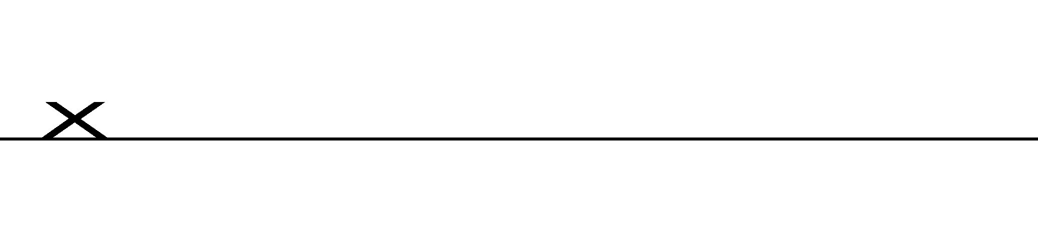
Name of Person Completing Form: Title of Person Completing Form:

Signature: Date:

The following person(s) has Signing Authority for contracts:
Name:
Title:
E-Mail Address:

